Independent United Order of Mechanics
The New England District Grand Lodge # 1
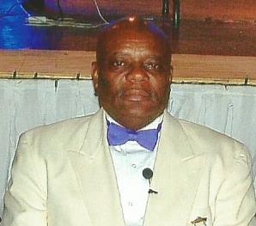
Right Worshipful District Grandmaster The Honorable John G. Ellis
Dear Brothers and Sisters of the Craft,
Harmony is the strength and support of all societies and my continued theme for The New England District. Elected for a third consecutive term as Worshipful District Grand Master of the New England District Grand Lodge No. 1, I am reaching out to our membership to work together in Unity. We must restore our valued traditions and the spirit of Mechanism that we once enjoyed and valued.
RT. HON. JOHN G. ELLIS
First, I want to express sincere thanks and gratitude to the Brothers and Sisters of this jurisdiction for once again having the confidence to elect me for a third term; this is truly appreciated. I spoke of Implementation, Growth, and Transformation at the Installation of the Districts Grand Lodge Officers.
Implementation of new Ideas, Growth within the District and Transformation are paramount to the road ahead. We begin the implementation process as we roll out our updated web site. We anticipate this will assist in bringing growth to the District by keeping us in touch with community, promote our programs, and attract new members through social media platforms such as Facebook and Instagram. We must promote programs that will not only attract, but also engage our youth.
Let me be clear about Transformation. This does not speak about our ritualistic work or our ancient customs. This change refers to our mindset and attitude towards each other; it is an inner transformation I speak of. If we are to maintain our Motto of Friendship, Truth and Brotherly Love; we must allow others to advance. Mentorship is just as essential to holding position. Brothers and Sisters, Old Ways will not Open New Doors. This prevents growth and breeds discontent, not Love. Change is ever-present and we must embrace it, not fight it. Some changes will be hard because they may shatter the status quo, but we must have the courage to make such changes. Change is Good and it can make a difference to our beloved Order. We must Think Boldly and Act Boldly and charge ahead to a brighter future.
Sincerely and truthfully yours,
Hon. John G. Ellis
Right Worshipful District Grand Master

